Phishing Simulation using Gophish
This document demonstrates the setup and execution of a phishing simulation using Gophish in a controlled educational environment for cybersecurity learning purposes.

Abstract
This project demonstrates how a phishing awareness simulation can be created using Gophish on Kali Linux. The objective of the project is to understand how phishing campaigns work, how attackers attempt credential harvesting, and how organizations can use simulations to train users against phishing attacks. The project includes the setup of Gophish, configuration of SMTP settings, creation of landing pages, email templates, launching campaigns, and monitoring captured results.

Introduction
Phishing is one of the most common forms of social engineering attacks where attackers attempt to trick users into revealing sensitive information such as usernames and passwords. Gophish is an open-source phishing framework used for security awareness training and simulations. This project focuses on understanding phishing mechanisms ethically in a controlled lab environment.

Objectives
- Understand phishing and social engineering techniques.
- Learn how Gophish works.
- Configure phishing campaigns in a safe environment.
- Analyze campaign statistics and user interactions.
- Gain practical cybersecurity experience.

Tools and Technologies Used
- Kali Linux
- Gophish
- Gmail SMTP
- Virtual Machine
- Web Browser

System Requirements
- Minimum 4 GB RAM
- VirtualBox or VMware
- Kali Linux installed
- Internet connection
- Gmail account with App Password enabled

Step 1: Launching Gophish
- Start Kali Linux Virtual Machine on your system. Search for gophish and click on gophish-start
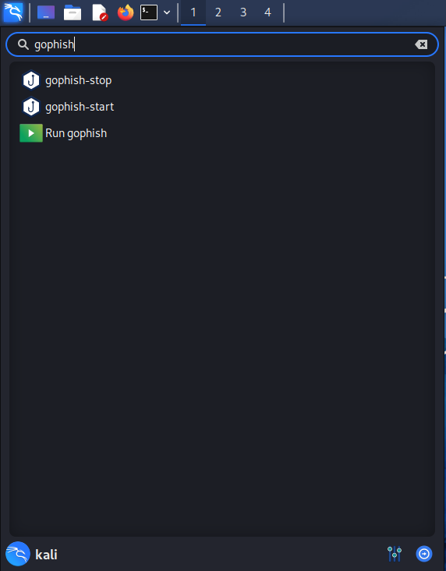

- Enter the password to start the service
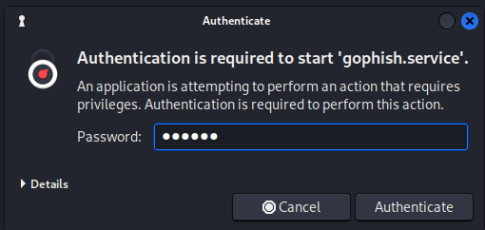

- Click the link that appears in the terminal and use the credentials given to log in.
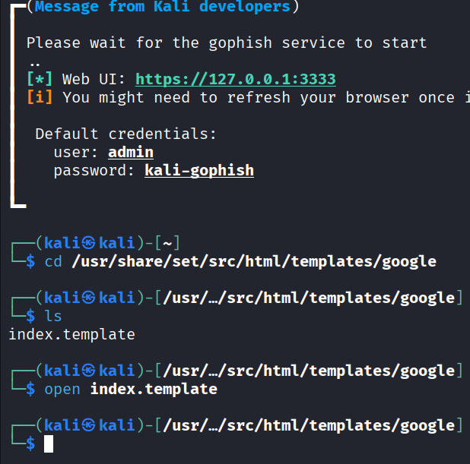

- A warning is received on the browser. Click on Advanced>Accept risk and continue.
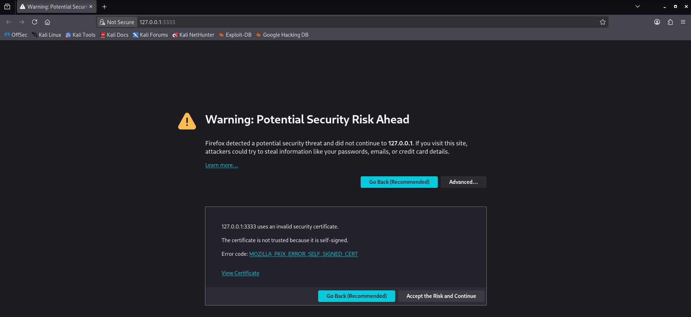

- After this, you will be redirected to the Gophish login page. Enter the credentials given in the terminal to log in.
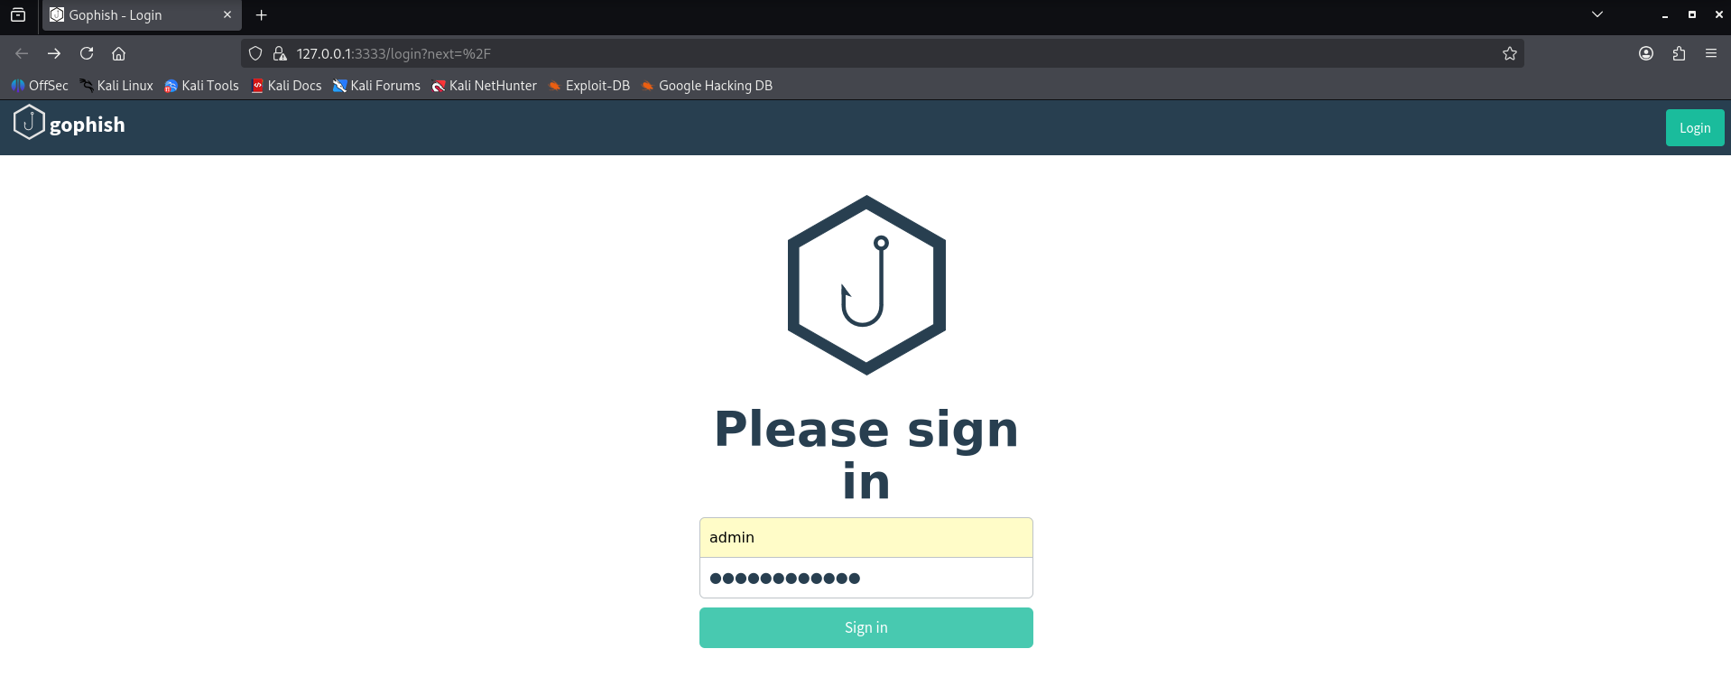

- Then reset your password
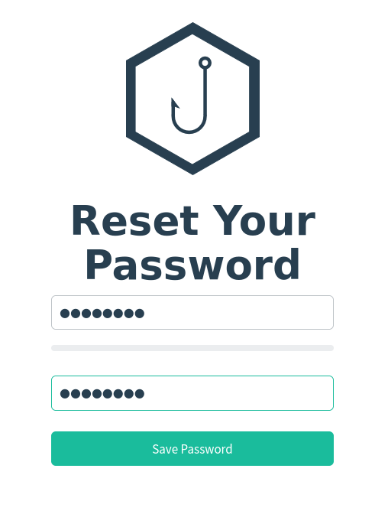
- You are now logged in to the Gophish webpage.
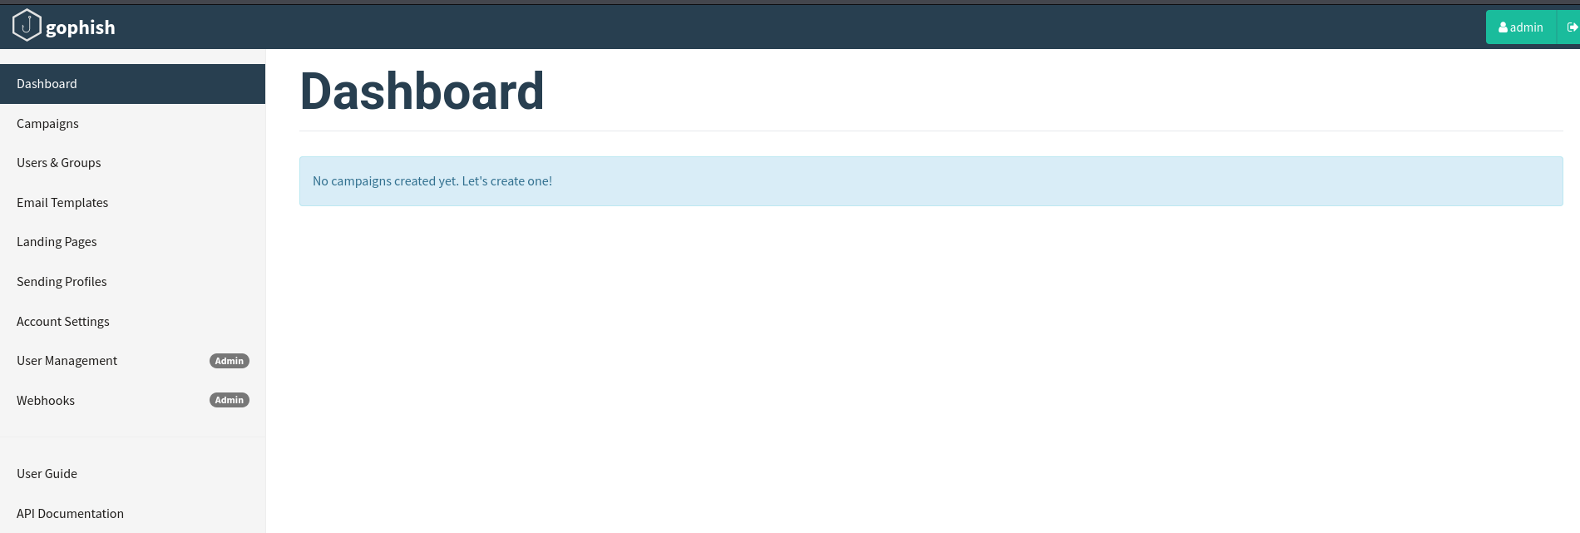

Step 2: Setting up Gmail account
- Log into your gmail account. Click on Manage Your Google Account.
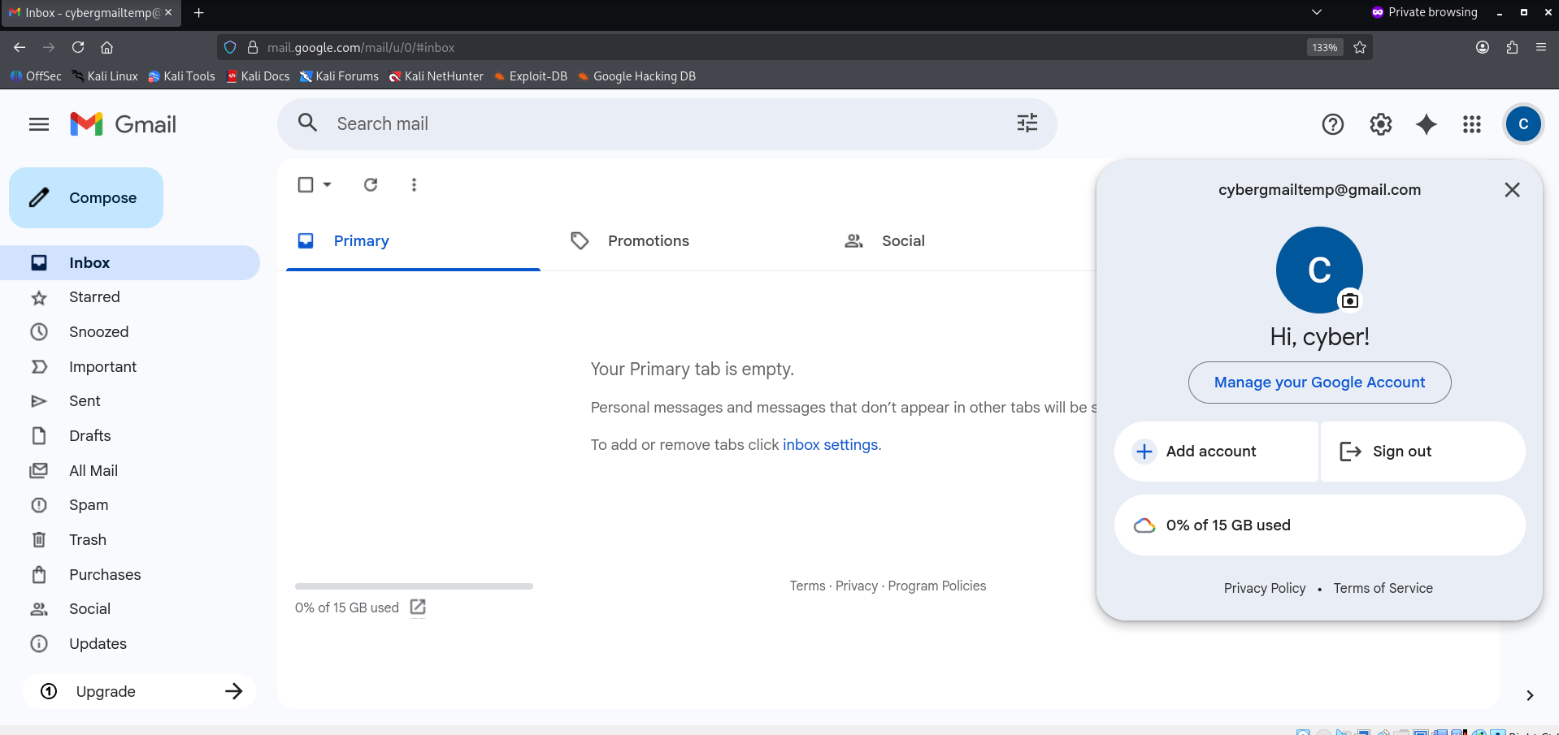

- Search for App Password and click on it. It will only appear if you have 2-step verification turned on.
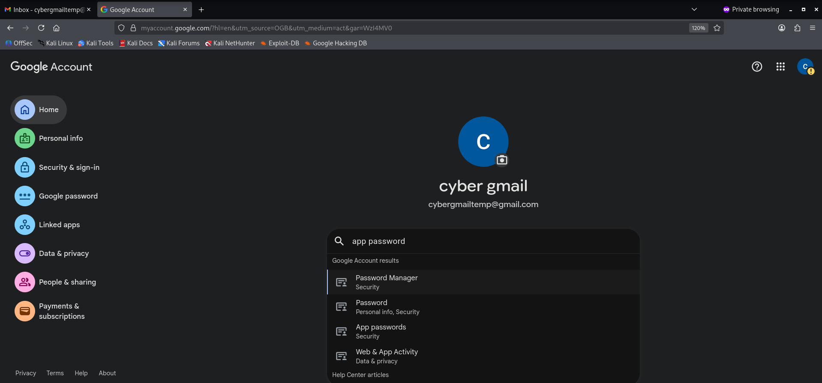

- Create an app password and name it GoPhish.
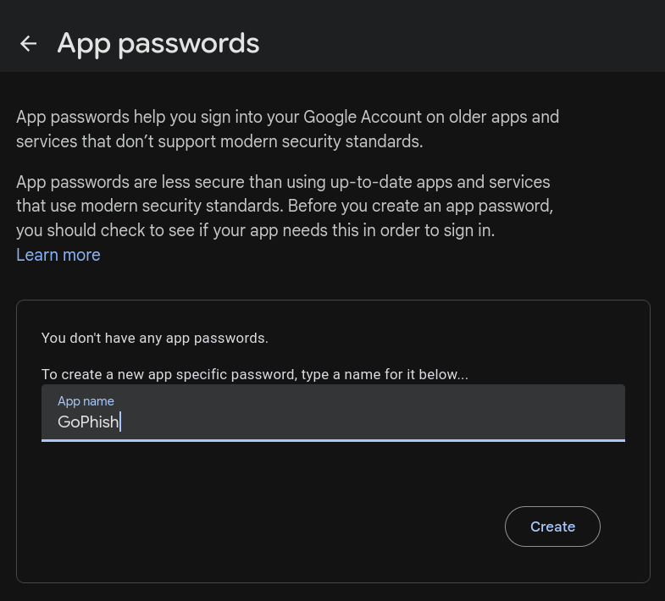

- Copy the app password you get.
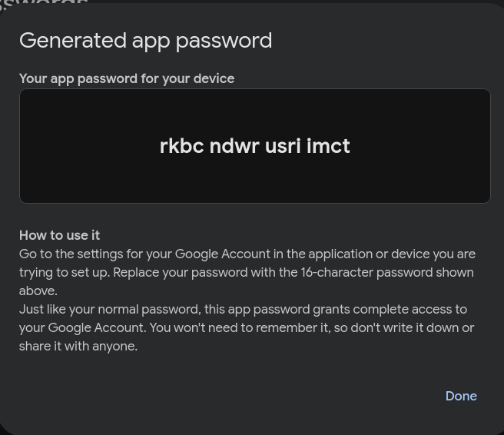

Step 3: Configuring Sending Profile
- In Gophish webpage, go to Sending Profile. Click on New to create a Sending profile with which emails will be sent. You will get a popup like the one below. Enter all details (adjust as needed). Here, we are using a Gmail SMTP server. In the password field, enter the password you copied in the last step.
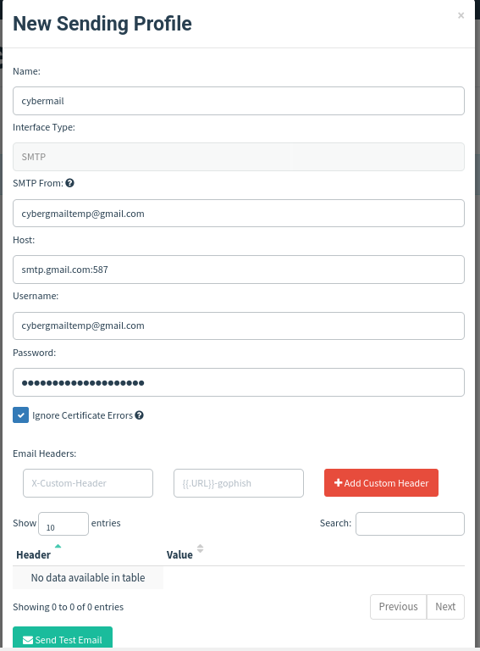
- Click on Send Test Email. Enter details as shown below and click on Send.
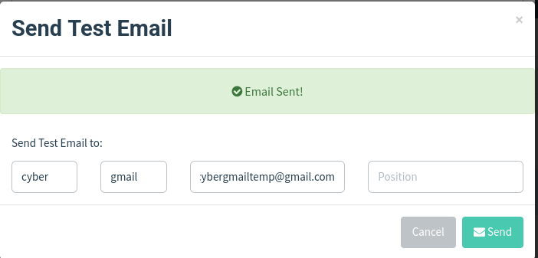

- Go back to your gmail account to check if the mail was received. If not received, check previous steps for any mistakes.
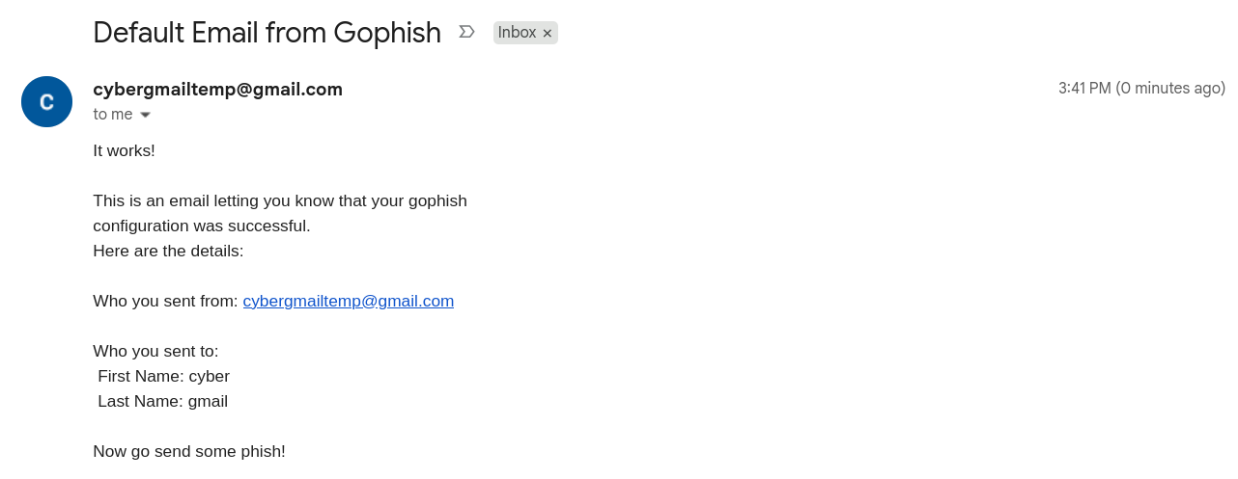

- You can verify mail authenticity by clicking on the small arrow below sender gmail. Your sending profile has been set up.
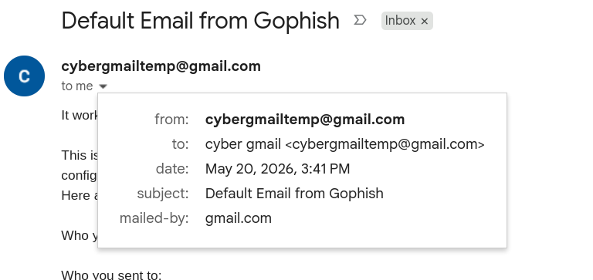

Step 3: Creating Landing Page
- In Gophish webpage, click on Landing Pages.
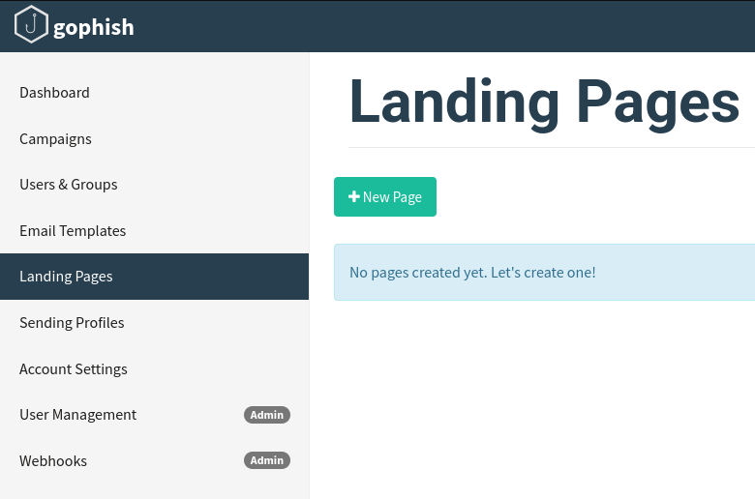

- In terminal, perform the commands as shown below. We use SET to get the google login page template to use as your phishing login page to make it look authentic.
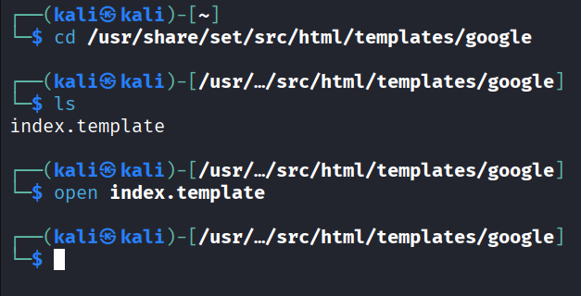

- This opens a webpage as shown below.
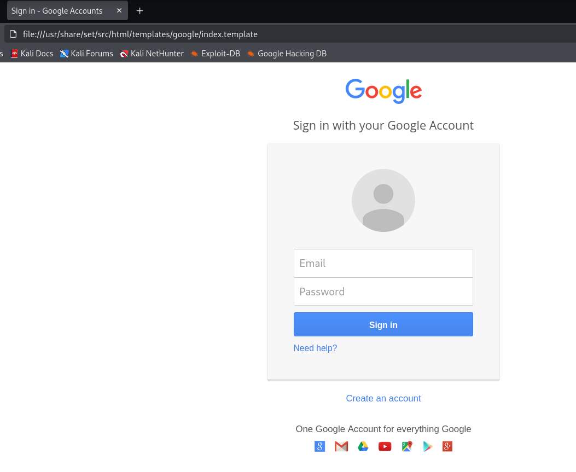

- Right click on the login page and then click on View Page Source.
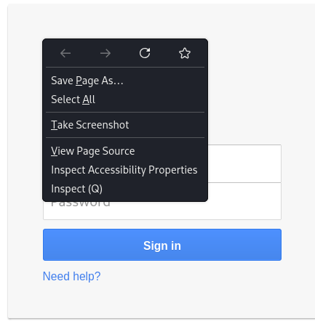

- You will be redirected to HTML code. Select the whole code by using Ctrl+A and then copy.
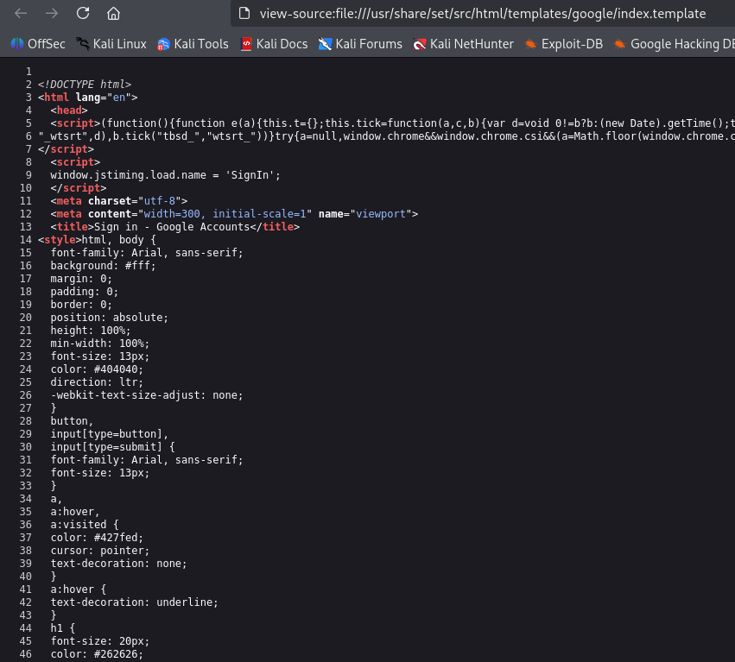

- In Gophish webpage, Click on New Landing Page and paste the code you just copied. Fill the rest of the details as shown below. Adjust as needed. Make sure that both the checkboxes are ticked, allowing us to get login data of user later. You have now made your phishing login page.
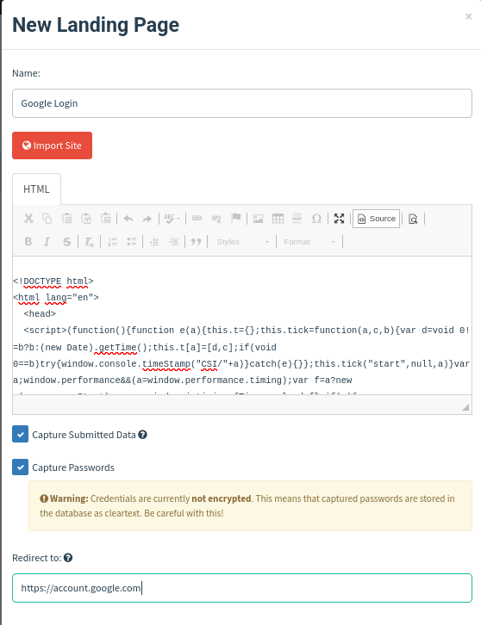

Step 4: Creating Email Template
- In Gophish, click on Email Templates.
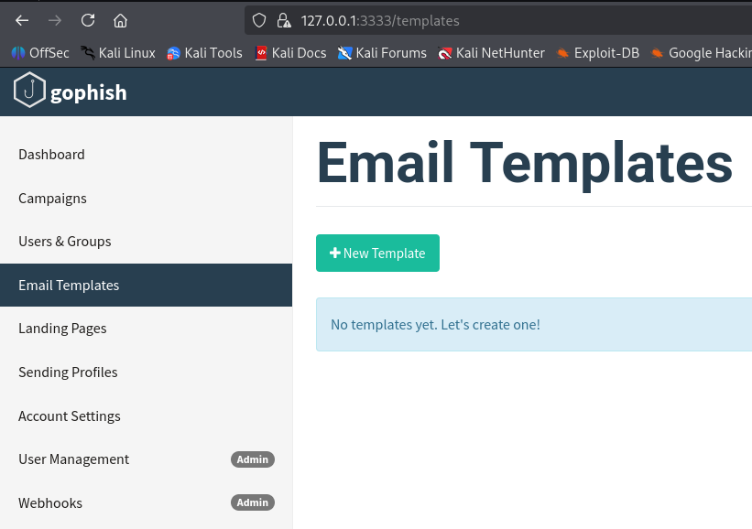

- In Gmail, log into your google account and open a google mail which looks authentic. The goal is to make the user think it is an actual email from google. Here, an email for 2-step verification activation is used. Click on the three dots on the top right and then click on Show Original.
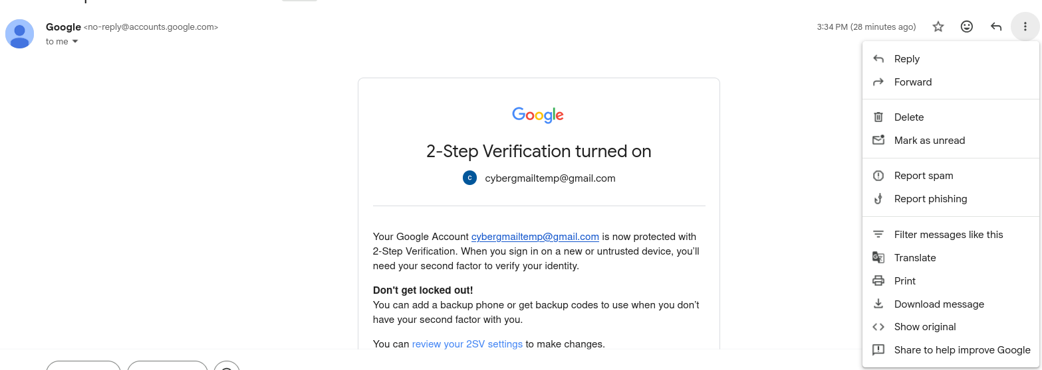

- Click Copy To Clipboard.
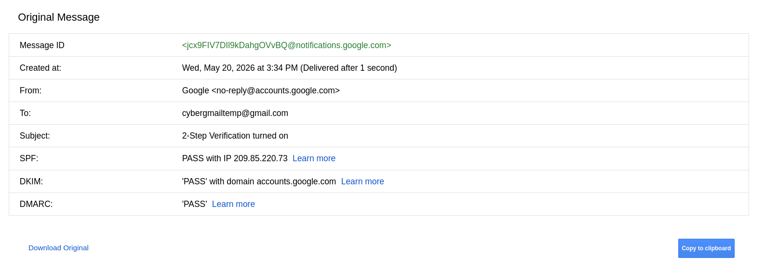

- In Gophish webpage, click on New Email Template. Click on Import Email.
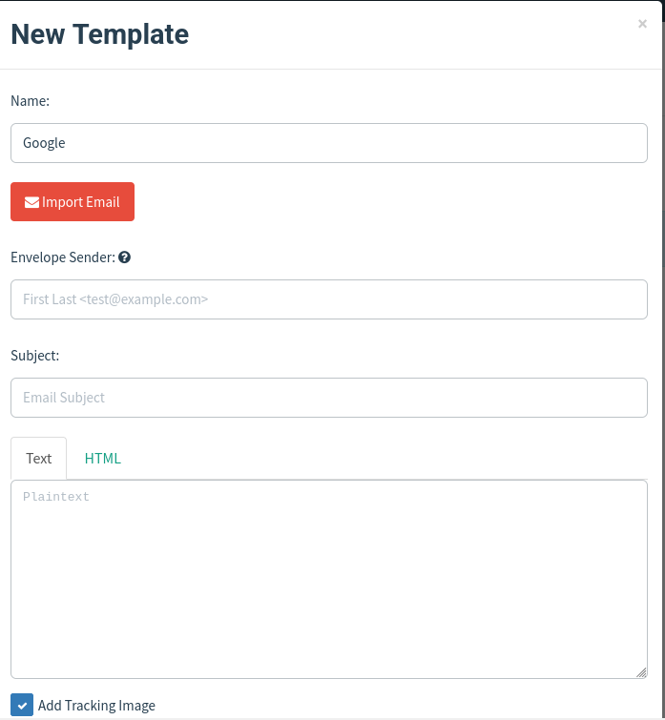

- A popup will appear. Paste the whole code you copied earlier. Click on Import. Make sure that the checkbox is ticked.
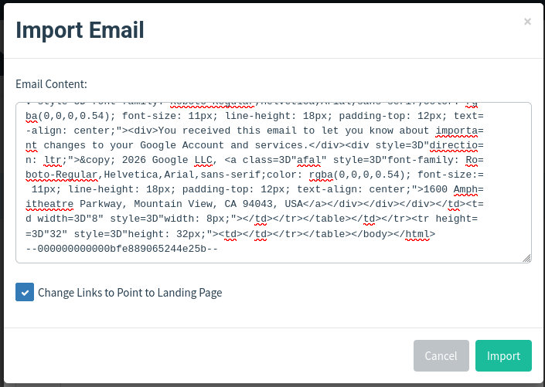

- Fill the rest of the details as shown below. Adjust as needed.
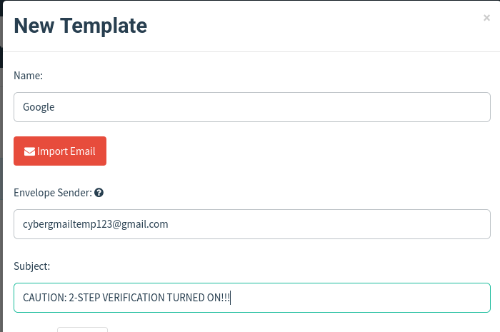

- You can see the preview of your phishing email template in the same window popup as shown below.
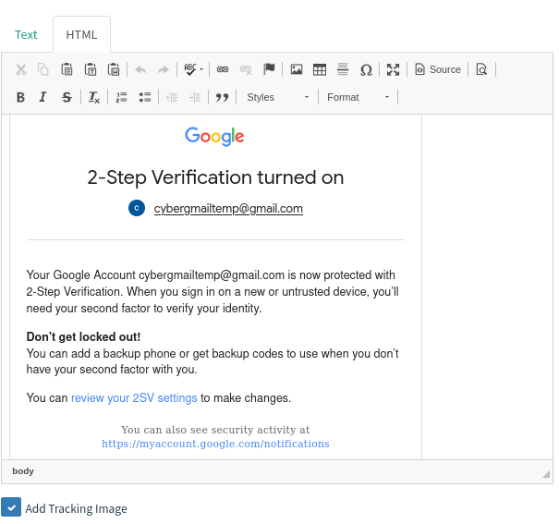

Step 5: Adding Target Users
- To now create a list of accounts to send phishing mails to, go to Users And Groups in the Gophish webpage.
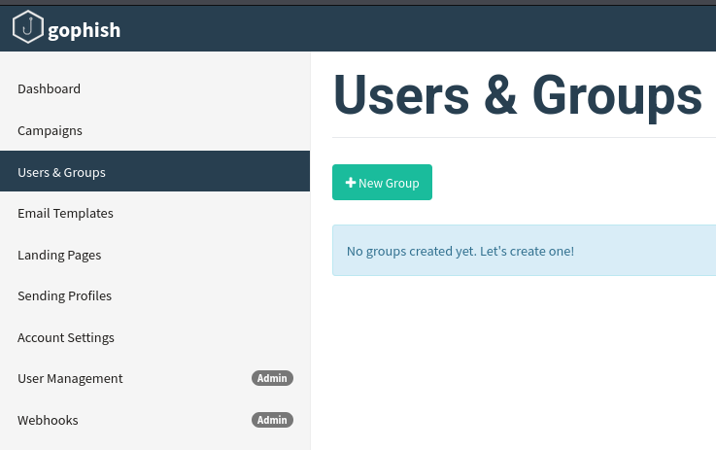

- Fill details as shown below. You can add accounts manually or import a list. These will be the targets who will receive the phishing mails.
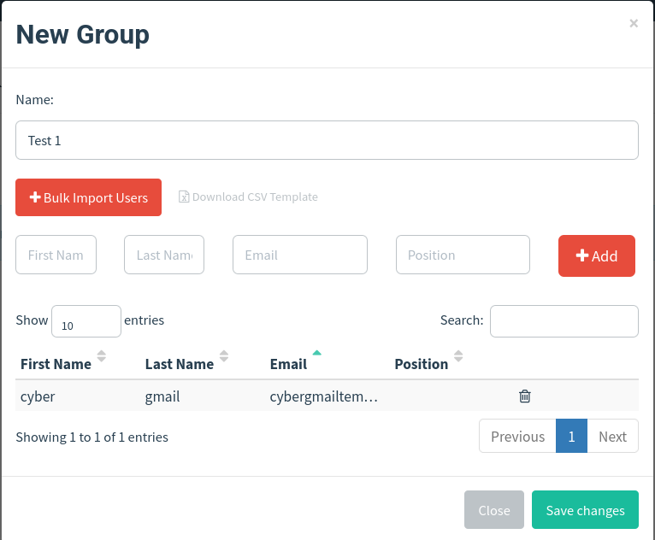

Step 6: Launching Campaign
- To start the phishing process, go to Campaigns in Gophish webpage.
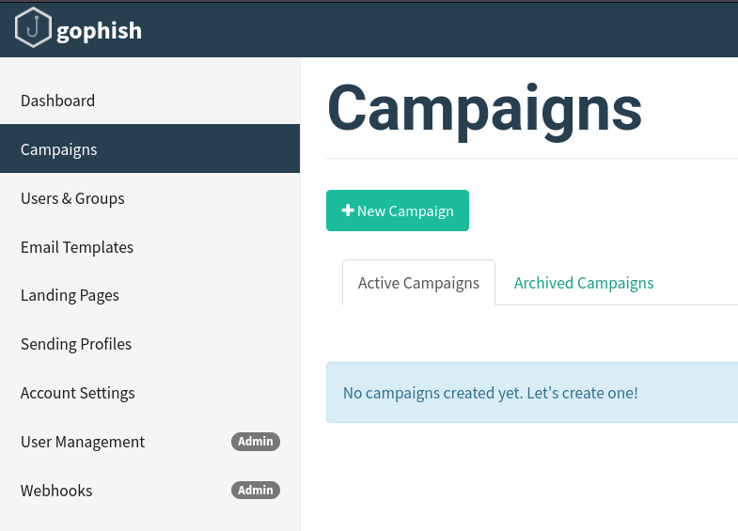

- Fill information as shown below and adjust as needed. In URL, enter the IP address of the virtual machine hosting GoPhish. Click on Launch Campaign.
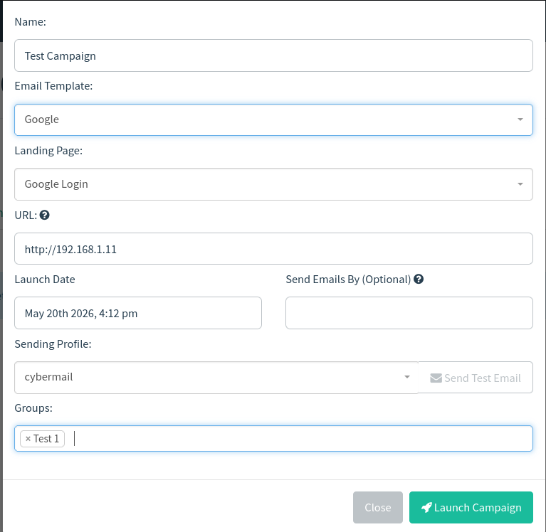

- Click Launch again.
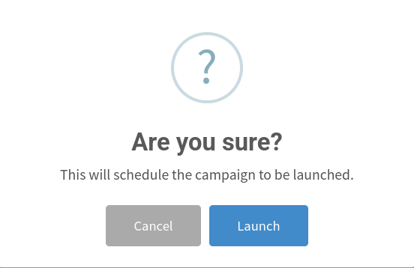

- Campaign has launched successfully.
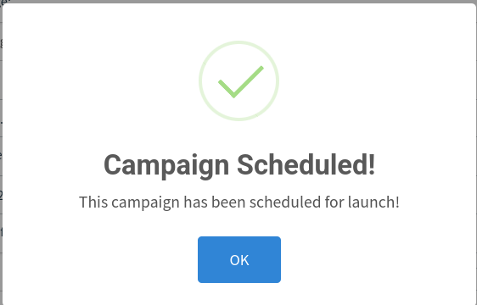

Step 7: Monitoring Results
- After clicking on OK, you will get redirected to the campaign dashboard where you can track the phishing process. In the image, it shows that an email has been sent. This can be verified by checking the recipient’s gmail account.
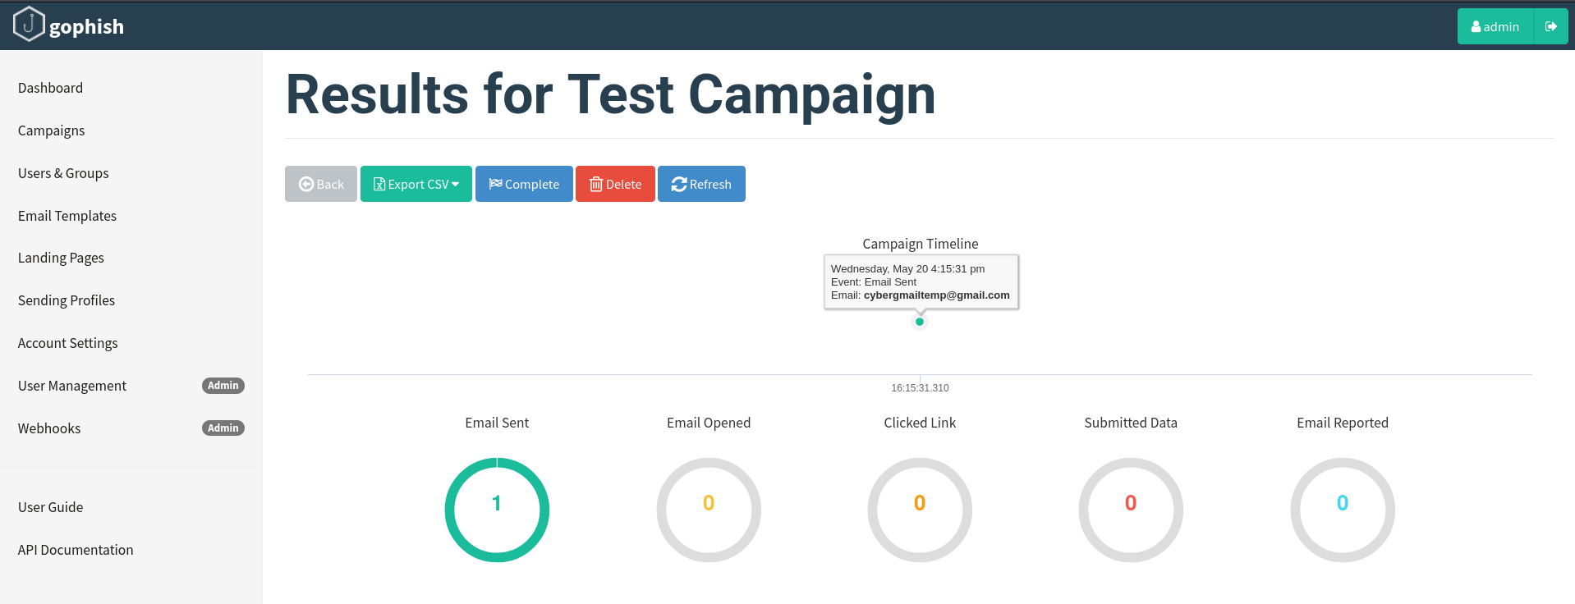

- After logging into the gmail account, we can see that a mail has been received.
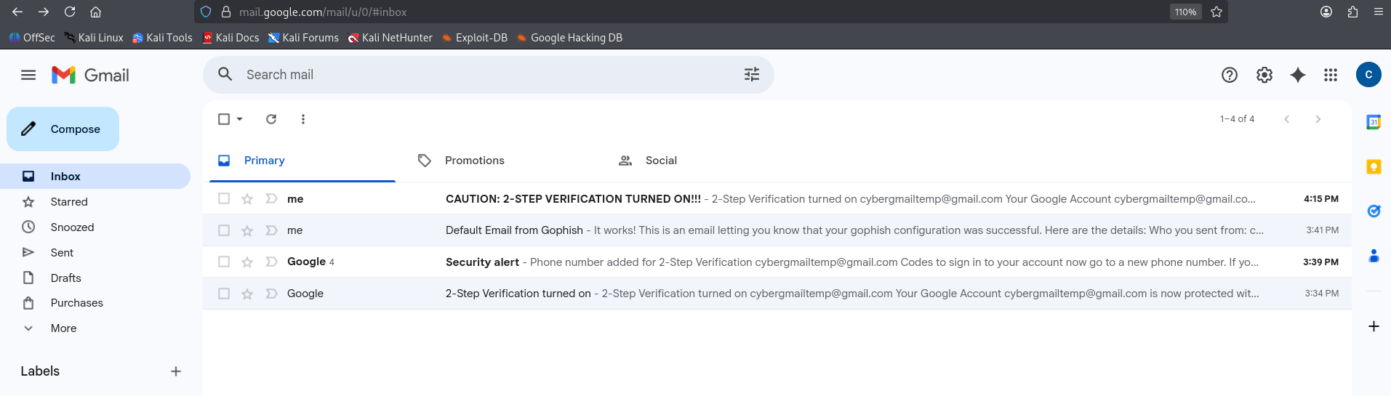

- Click on the mail and click on the link present in the underlined gmail account.
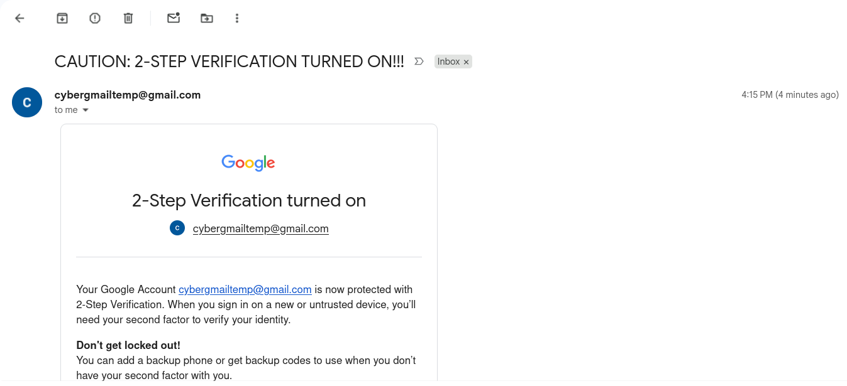

- Authenticity of gmail can be verified by clicking the small arrow below the sender gmail address.
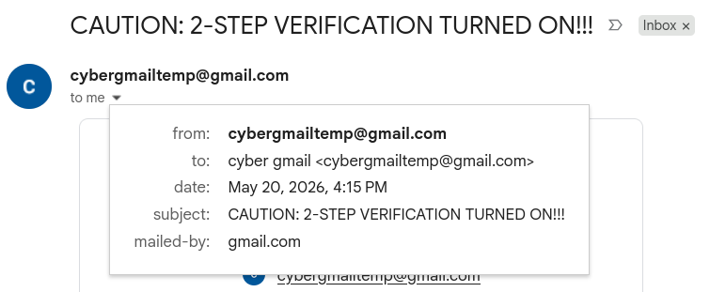

- After clicking the phishing link, we get redirected to the login page. You can recognise that it is a phishing link by the “Not Secure” sign next to the link in the search tab. Enter your username and password to complete the phishing process.
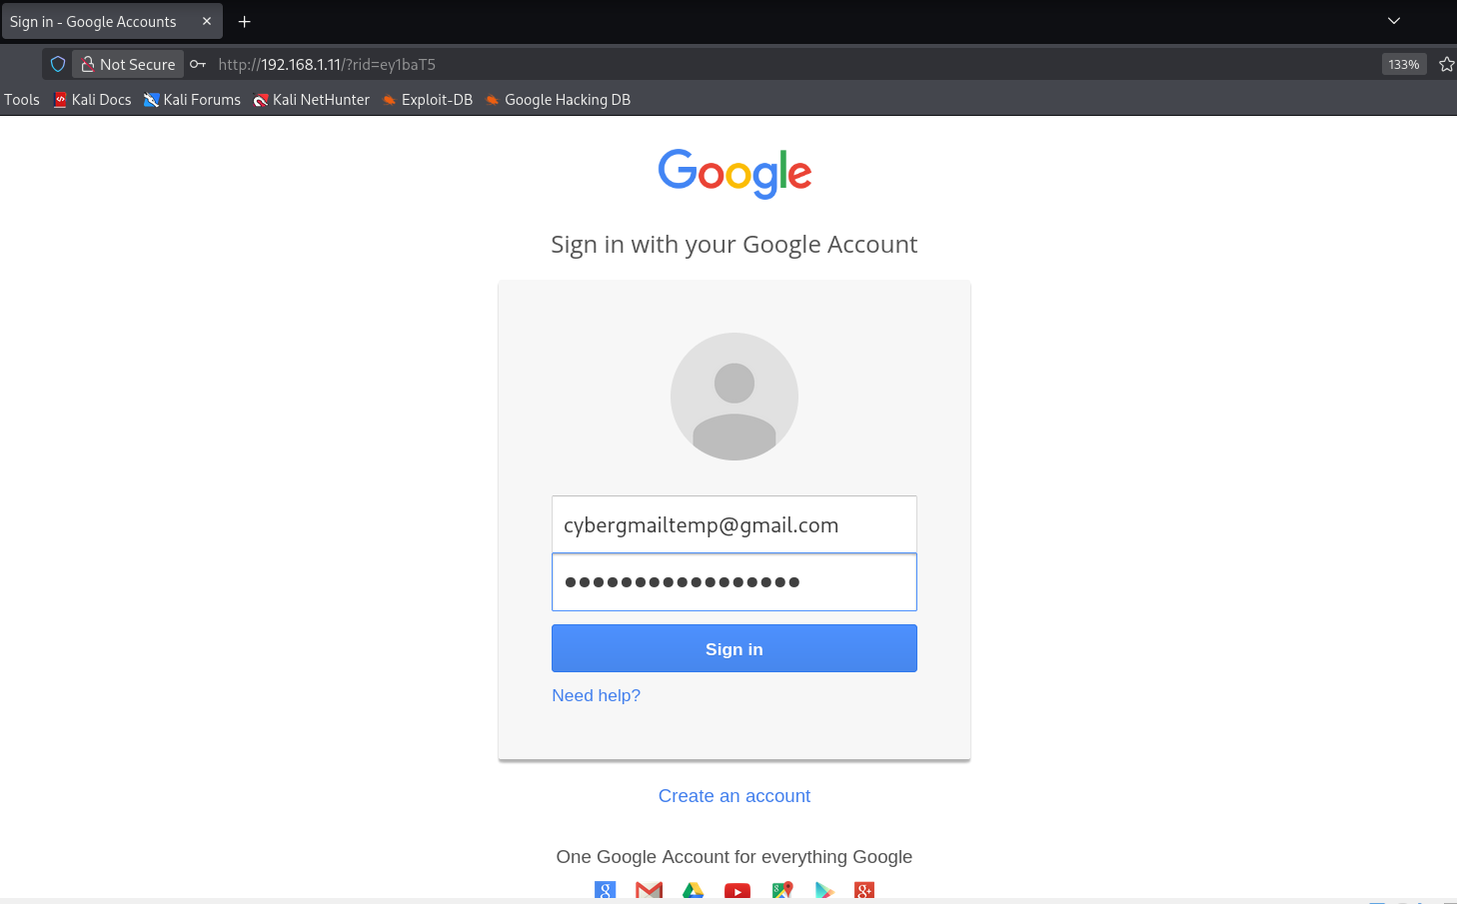

- After clicking on Sign In, you will be redirected to your account page.
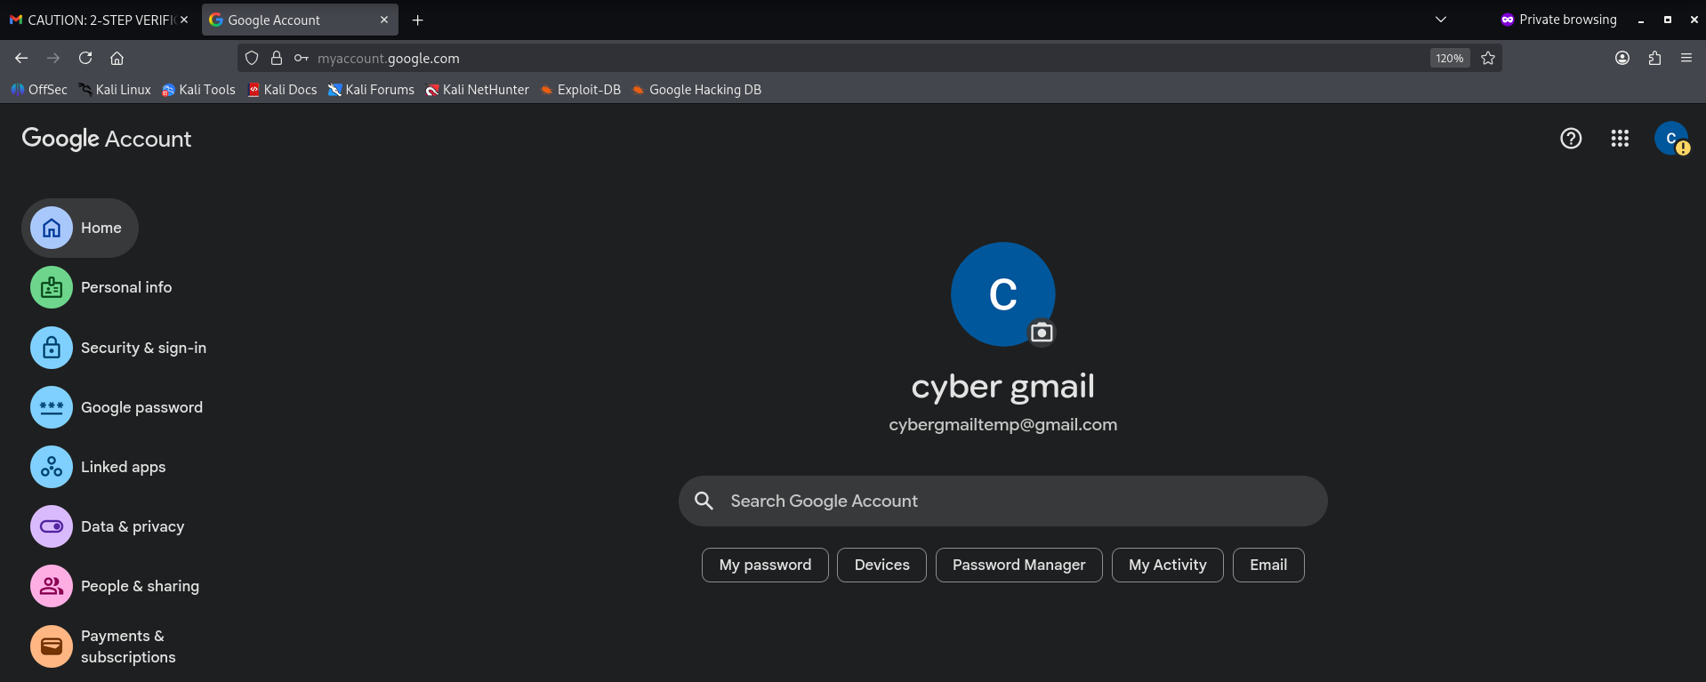

- In Gophish webpage, we can see the updated phishing process. Email has been sent, opened, link clicked and details submitted.
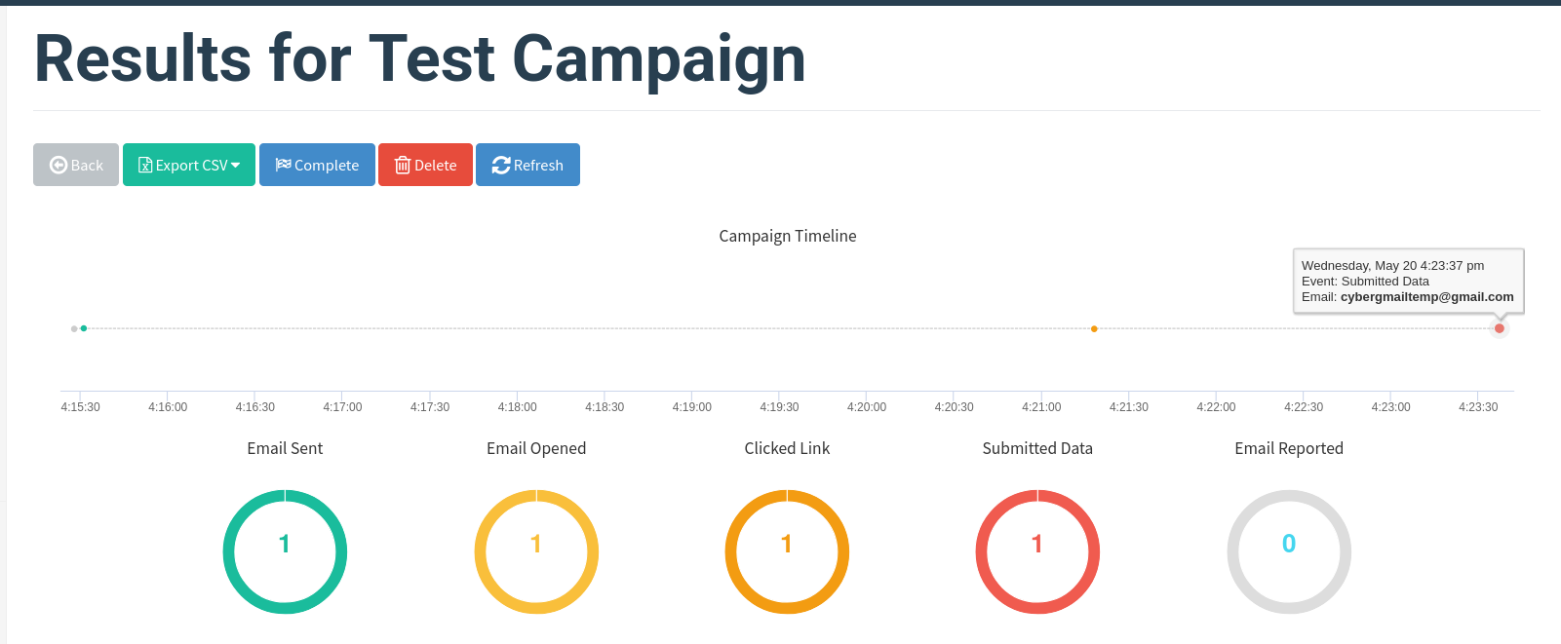

- Scroll down and click on the small arrow next to the target to see further details.
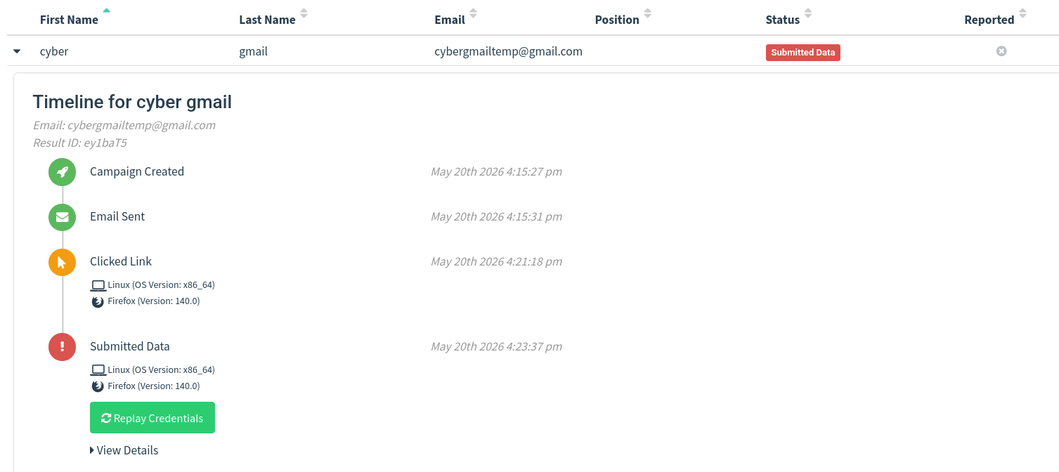

- Click on View Details at the end to see login username and password. Phishing process has been successfully completed. Click on Complete Campaign.
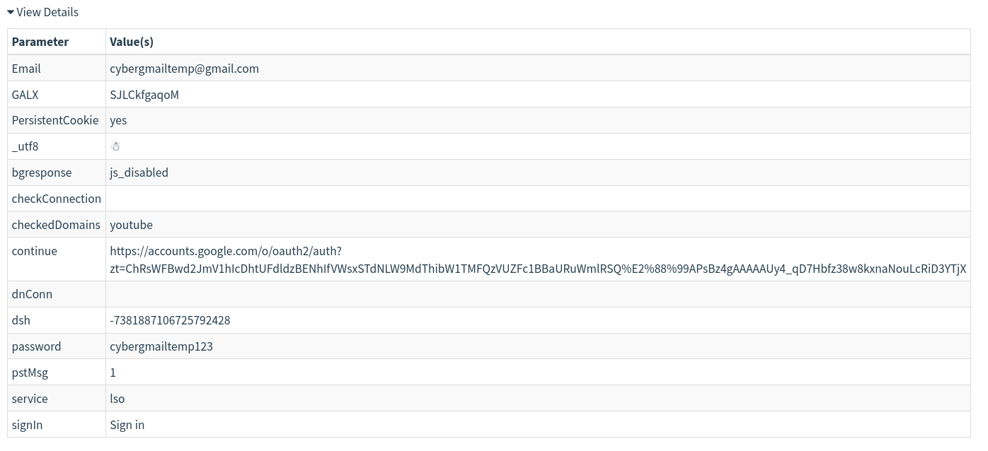

Results
The phishing simulation successfully demonstrated how phishing attacks are conducted and monitored. The project showed how user interactions can be tracked and analyzed for security awareness training.

Advantages
- Helps understand phishing techniques.
- Useful for cybersecurity awareness training.
- Easy to configure and monitor.
- Open-source and lightweight.

Limitations
- Requires ethical and legal authorization.
- SMTP providers may block suspicious activity.
- Not suitable for real-world unauthorized testing.

Ethical Considerations
This project was performed only for educational and awareness purposes in a controlled environment. No unauthorized access or malicious activity was performed. The project follows ethical cybersecurity practices.

Conclusion
The project provided hands-on experience with phishing simulations using Gophish. It improved understanding of phishing attacks, email spoofing concepts, landing page creation, and campaign monitoring. The project also highlighted the importance of cybersecurity awareness and ethical hacking practices.

